Capstone Project – Intelligent Document Processor
Langraph Process flow:
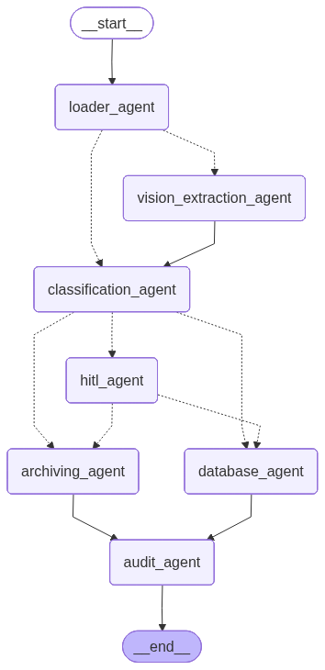
HITL Screen: 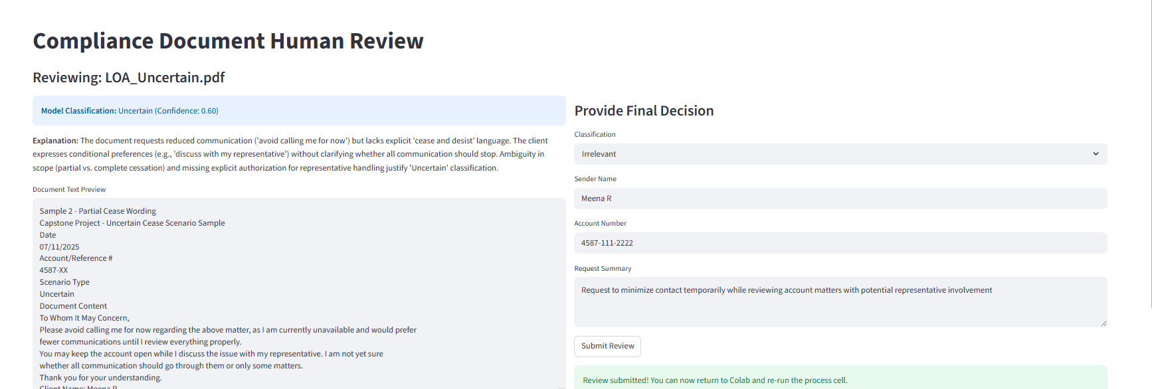
High Level Process Flow:
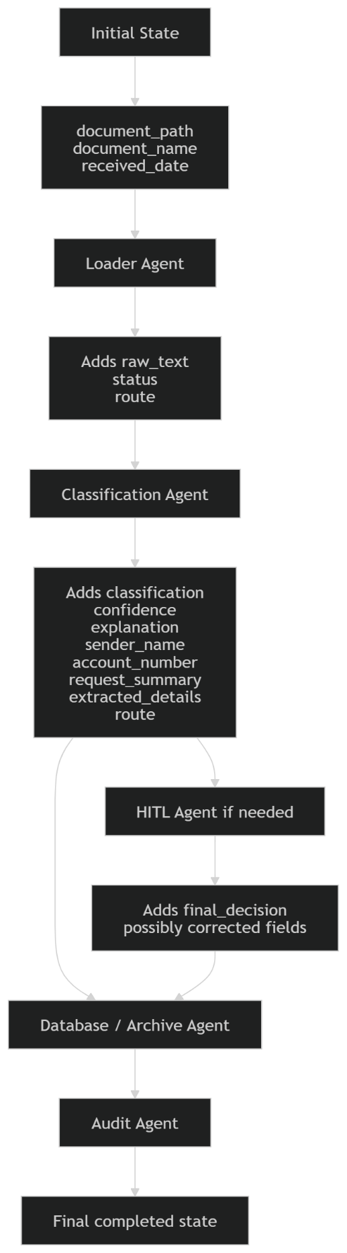
Cease Records – Saved in DB:
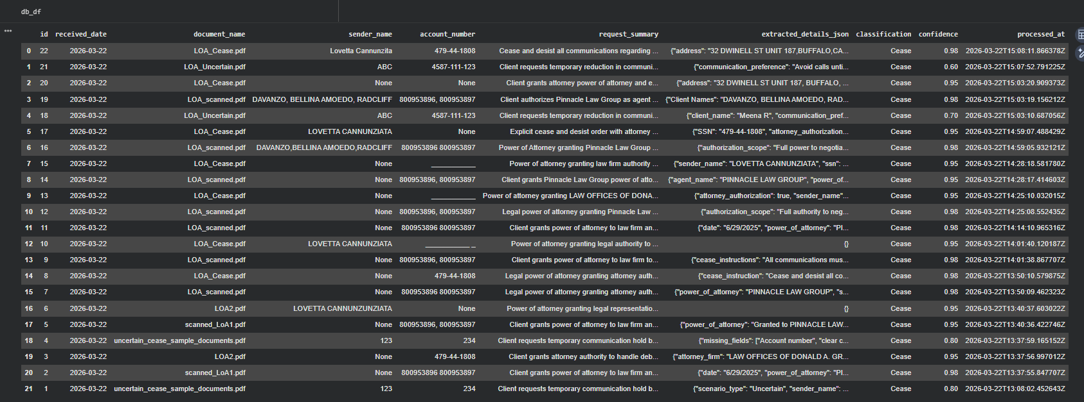

Irrelevant Records – Saved in Flat File:
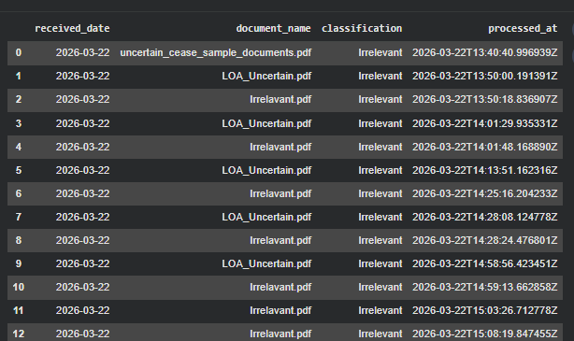

Audit Log:
